L1-INTERMEDIATE ASSESSMENT
MYSQL-RDBMS
MUKESH N
12572

Crowdfunding Platform This case study focuses on the development of a crowdfunding platform that facilitates the funding of projects through contributions from supporters. The system handles campaign creation, fund contributions, and progress tracking. The database schema supports the management of crowdfunding activities and financial transactions.



WHAT? HOW? WHY? WHY NOT?
1.What are the modules in crowdfunding platform?  Admin module  User module  Supplier module  2.What are the functionalities of admin module?  a. admin can login  b. admin can collect user details  C. Admin can collect supplier details.  d. Admin can maintain transaction  3.What are the functionalities of the user?  a. user can get money.  b. User can apply for help(fund).  4.What are the functionalities of supplier module?  a. Supplier can provide fund/help.  b. Supplier can get user details through admin.  5.What are the functionalities of non-registered module?  a. non-registered user can need funds.  b. nonregistered user can provide fund | Method 1: admin can login using his personal information  Method 2: admin can login using social media  Method 3: admin can login using employee id and password  Method 1: admin can collect user details who really need fund who are very poor and sick  Method 2: admin can collect user details as such  Method 3: Admin can collect user details whomever he/she known by giving priority  Method 1: admin can collect supplier details who is willing to provide fund  Method 2: admin can collect supplier details who is ready to donate fund by proper investigating.  Method 3: admin can collect supplier details from neighbors.  Method 1: admin can maintain transaction by which they will maintain the amount, time, from whom we received the amount also the complete details in a database.  Method 2: admin can maintain the transaction details as such.  Method 3: admin can maintain the details of transaction in handwritten format.  Method 1: User can get money from trusted suppliers through application.  Method 2: user can get money/fund from untrusted parties  Method 3: user cannot get fund.  Method 1: User can get help by applying through the application.  Method 2: User can get help from anyone  Method 3: User can may or may not get help.  Method 1: Supplier can provide fund as they like.  Method 2: supplier can provide fund to the poor who feel very difficult to earn money through application  Method 3: supplier can may or may not provide fund.  Method 1: Supplier can get user information through admin to provide fund without data loss.  Method 2: Supplier can get user information through third party so there may be chance of data duplication.  Method 3: Supplier can get user details from admin and misusing the data  Method 1: Nonregistered user can directly ask help.  Method 2: Nonregistered user can get help after applying.  Method 3: Nonregistered user can get help from unknown(third-party)  Method 1: nonregistered user can provide fund to the needful through applying through application  Method 2: Nonregistered user can provide amount to the people they like  Method 3: Nonregistered users may or may not provide funds. | Method 3 is suitable because login in using employee id and password will be suitable since it is a public platform by which we can avoid data loss  Method 1 is most suitable because we need to collect user details who is sick or poor.  Method 2 is suitable because collecting supplier details is most important in crowdfunding application, we need to collect fund only from trusted parties.  Method 1 is most suitable because maintaing the complete information in a database will be proof by which we can avoid data inconsistency.  Method 1 is most suitable because getting fund through application will have proof so that we can help the one at any time.  Method 1 is most suitable because applying through application will have proof so that we can help the one at any time.  Method 2 is most suitable because providing fund is very important nowadays because there may be chance of having duplicates.  Method 1 is most suitable because getting information for providing fund is important rather than user information is also more important.  In this scenario both method 1 and method 2 will be suitable but to be more specific they can get help from others after applying.  Method 1 is most suitable because applying through application and providing fund is encouraged in crowdfunding application | Method 1 and Method 2 is not suitable because login in using personal information and other information will leads to data loss  Method 2 and Method 3 is not suitable since it is crowdfunding application, we need to help who is poor also we need not help who has all facility.  Method 1 and Method 3 is not suitable because few supplier can give assurance that they will pay but they won’t follow that.  Method 2 and Method 3 are not suitable because since it is money related application, we must have proof for all transaction maintaing in handwritten notes will not be entertained.  Method 2 and Method 3 are not suitable because getting funds as such or getting funds from anyone will not be encouraged.  Method 2 and Method 3 are not suitable because getting money from untrusted parties will not be entertained.  Method 1 and Method 3 are not suitable because there is no use in providing funds to a well-settled person.  Method 2 and Method 3 is not suitable loss of user information is not encouraged.  Method 3 is not suitable because if they get help from third party there may be chance of data loss.  Method 2 and Method 3 is not suitable because proving help is entertained but helping others without applying is not encouraged in crowdfunding application

ER-DIAGRAM:
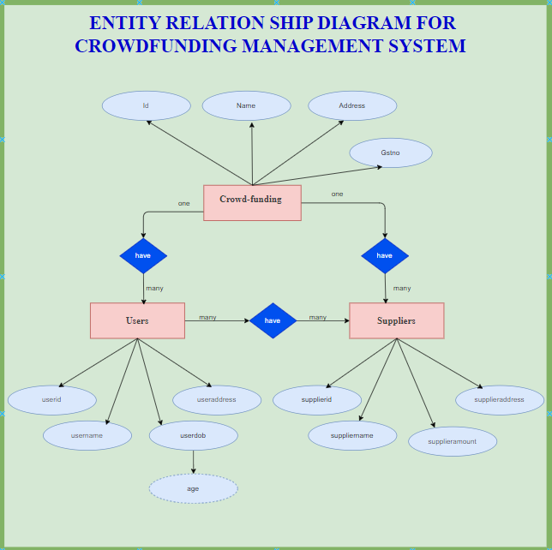

Relationships:
- One funding can have many users (one to many)
- One funding can have many suppliers (one to many)
- Many users can have many suppliers (many to many)

MYSQL-QUERIES:
Table 1: crowdfund
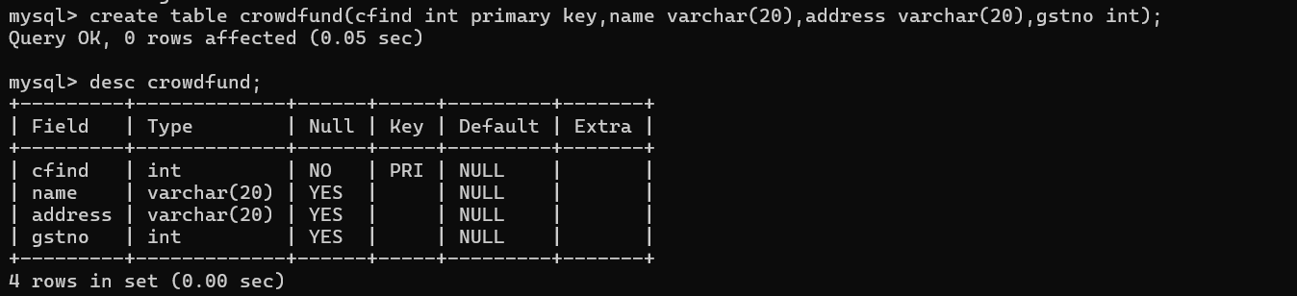

Inserting values to crowdfund:
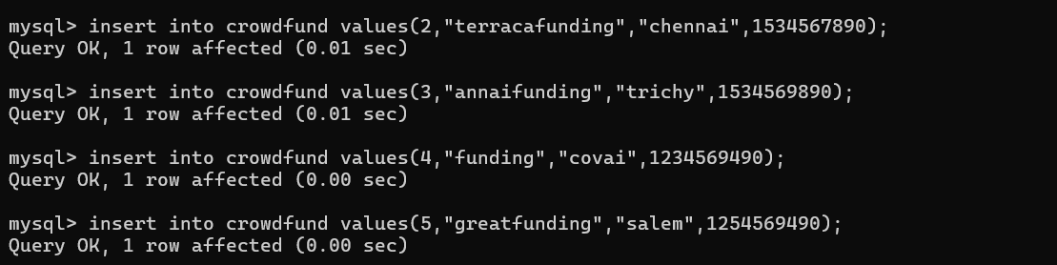

Selecting the details of crowdfund:
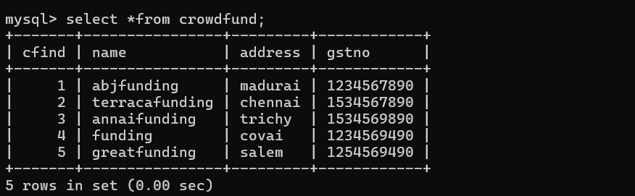
Table 2: Users
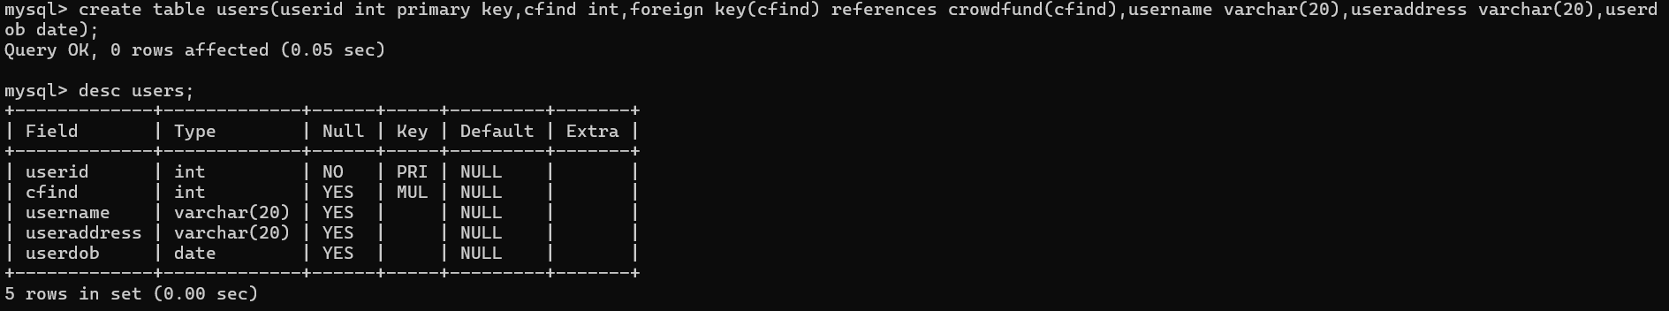

Inserting into users:
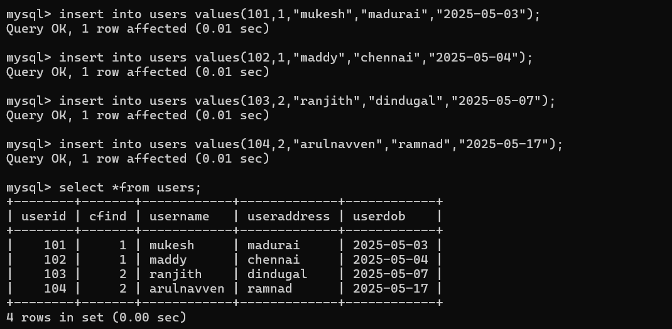

Relationship mapping:
One crowdfunds have 2 users namely (Mukesh and Maddy) which indicate one to many relationship
Table 3: Suppliers
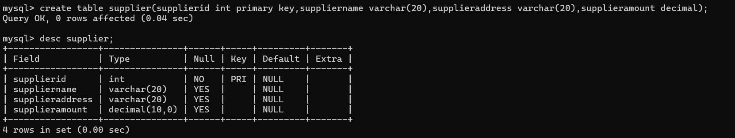

Inserting into suppliers:
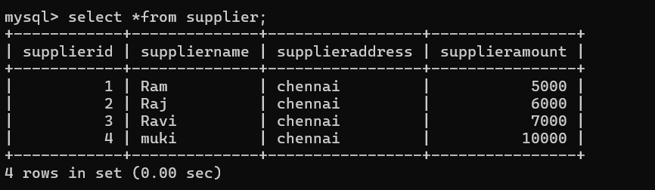

To establish a relationship, I have created a new table called details which is not most important.
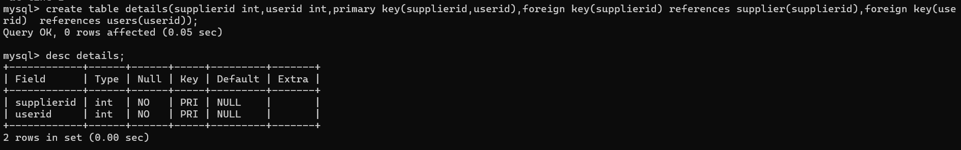

Inserting values:
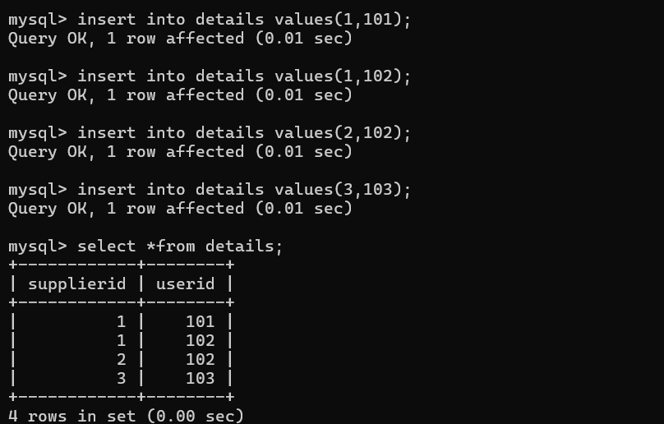

Relationship mapping:
From the above table it clearly indicates many users can have many suppliers and many suppliers can have many users (many to many).
Count the total no of crowdfund groups:
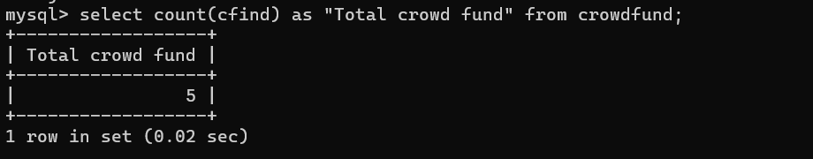

Calculating length of supplier name:
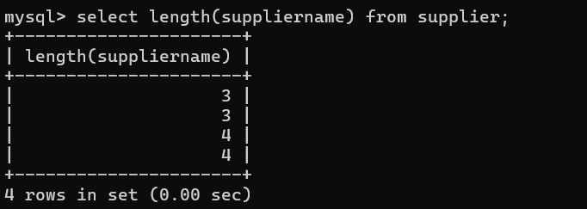

Joining two tables:
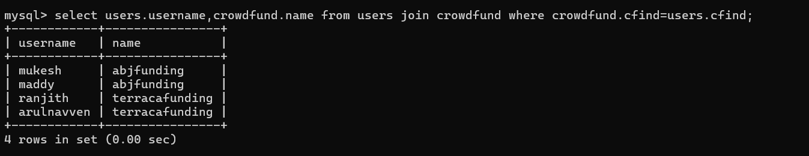
Updating the table crowdfund (name=funding to thaifunding)
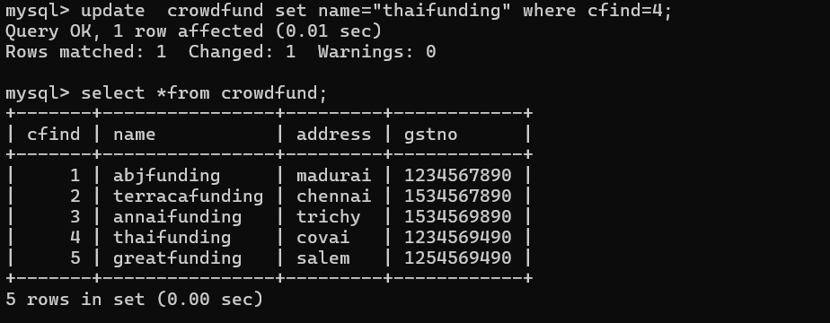

Updating the supplier address (Chennai to Madurai)
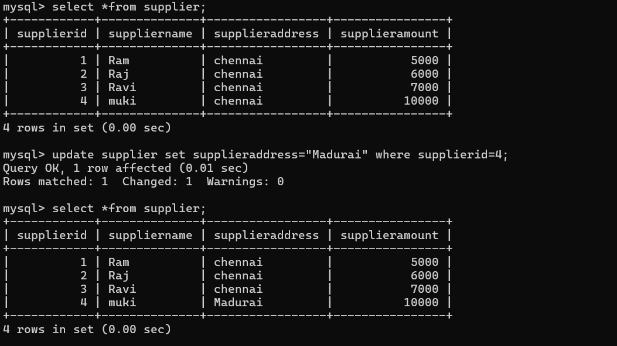
Deleting the record:
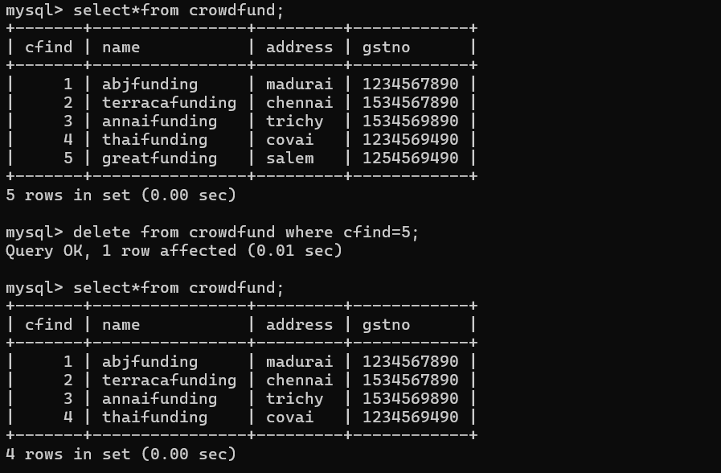

Truncating the table:
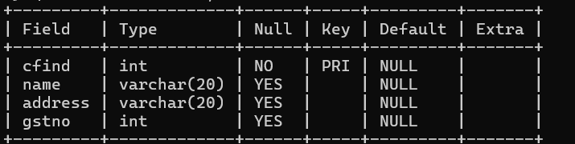 we will be having only column without attributes

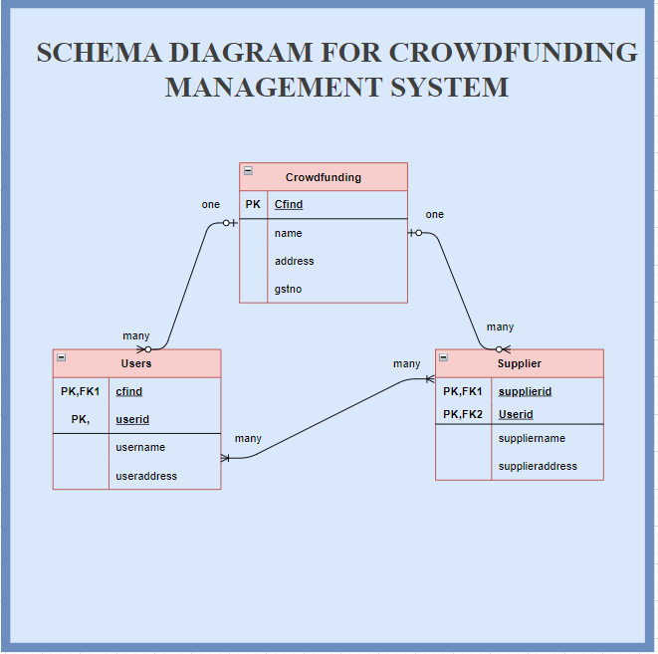

Git url: https://github.com/Mukesh190304/mysqlassessment.git

